Student Name

Chemistry Unit 4

AOS 2 Supplying And Using Energy: Outcome 2 Part B

Question 4
Using the equations below:
2C(s) + 2O₂(g) 2CO₂(g) ΔH = – 780 kJ/mol …equation (1)
Mn(s) + O₂(g) MnO₂(s) ΔH = – 520 kJ/mol …equation (2)
What is the ΔH value in kJ/mol for: MnO₂(s) + C(s) Mn(s) + CO₂(g)
- + 910
- – 910
- + 130
- – 130

Question 11
In an electrolysis experiment, measurements reveal that 0.88 mole of material is formed at the anode and 1.76 mole of material is formed at the cathode. The electrolyte could be:

- molten MgCl₂
- 0.1 M CuBr₂
- 0.1 M NaCl
- 5.0 M NaCl

Question 13
A student prepares 1.0 M aqueous solutions of AgNO₃, Ni(NO₃)₂ and NaNO₃.
Equal volumes of each solution are placed in separate beakers, identical platinum electrodes are placed in each beaker and each solution undergoes electrolysis with 1.0 ampere applied for 10.0 minutes under SLC. Each cathode is then dried and weighed to determine mass change.
Assume that the concentrations of the solutions have decreased only slightly. In order of increasing mass, the metals deposited on the three cathodes are likely to be:
- nickel, sodium, silver.
- silver, nickel, sodium.
- sodium, silver, nickel.
- sodium, nickel, silver.

Question 1 (5 marks)
Fuel cells offer a clean and efficient way of producing electricity directly from chemicals.
- What main feature makes a fuel cell different to a primary or secondary cell?
____________________________________________________________________________________________________________________________________________________________________________________________________________
1 mark
The redox reaction between ethanol and oxygen can be utilised in a particular fuel cell. The overall reaction between ethanol and oxygen is outlined below:
C₂H₅OH_{(l)} + 3O_{2(g)} 3H₂O_{(l)} + 2 CO₂ _{(g)}
- An acidic electrolyte is used in the ethanol/oxygen fuel cell.
Write a balance half-equation for the reaction occurring at the:
- Cathode

____________________________________________________________________________________
- Anode

___________________________________________________________________________________
1 + 1 = 2 marks

Question 3 (11 marks)
The Betts electrolytic process is an industrial process for producing highly purified lead. In a small-scale trial, an impure sample of lead is used as one electrode and a small plate of pure lead is used as the other electrode. The electrolyte used contains a mixture of an acid solution and lead (II) ion solution.
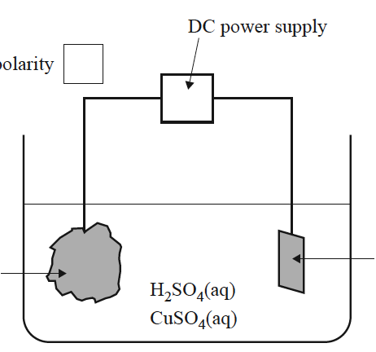
lump of impure lead
pure lead plate
$${\text{H}}^{\text{+}}\text{(aq)}$$
$${\text{Pb}}^{\text{2+}}\text{(aq)}$$

polarity

- Indicate in the box labeled ‘polarity’ on the diagram above, the polarity of the impure lead electrode.
______________________________________________________________
1 mark

In a trial experiment, the electrodes were weighed before and after electrolysis. The results are provided in the following table:
 | Mass of lump of impure lead (kg) | Mass of pure lead (kg)
before electrolysis | 3.72 | 1.23
after electrolysis | 0.89 | 3.30

- Using the results above:
  - Calculate the percentage purity of the lump of the impure lead
.
________________________________________________________________________________________________________________________________________________________________________________________________________________________________________________________________________________________________________________________________

  - Indicate an error that could have occurred in the trial experiment that would lead to the calculated percentage purity to be higher than that of the true value.

________________________________________________________________________________

3 + 1 = 4 marks

- Lumps of impure lead typically contain impurities such as iron, zinc and copper. The iron and zinc in the impure lumps are oxidised during the electrolytic process and exist as ions in the electrolyte. The copper is not oxidized and forms an insoluble sludge at the base of the cell.
Why is it important that the copper is not present as cations in the electrolyte?

______________________________________________________________________________________________________________________________________________________________________________
1 mark

- The conditions in the electrolytic cell shown in the diagram are carefully controlled to ensure a high degree of lead purity and electrical efficiency.
Use the mass of pure lead deposited that is given in the table in part b. to determine the time, in days, taken for this electrolysis reaction to be completed. Assume the current was a constant 5.7 A.

______________________________________________________________________________________________________________________________________________________________________________________________________________________________________________________________________________________________________________________________________________________________________________________________________________________________________________________________________________________________________________________________________________________________________________________________________________________________________________________________________________________________________________________________________________________________________________________________________________________________________________________________________________________________________________________________________________________________________________________________________________________________

6 marks

